WEEKLY INTERNSHIP PROGRESS REPORT
Intern: Renu Gehlot
Institution: MBM University, Jodhpur
Project: AI-Based PDF Chatbot Development
Reporting Period: Week 2 (Day 4 – Day 8)

Weekly Summary
During this week, I focused on strengthening my understanding of Natural Language Processing (NLP), embeddings, vector databases, and retrieval techniques used in modern AI chatbot systems. Along with theoretical learning through tutorials and documentation, I explored the practical aspects of installing required libraries and implementing basic prototypes for embeddings and similarity search.
The activities performed this week helped me understand how extracted text from PDF documents can be transformed into numerical representations and efficiently retrieved using semantic search techniques. These concepts form the foundation of Retrieval-Augmented Generation (RAG) systems, which will be implemented in the later stages of the project.

Day 4: Understanding NLP Fundamentals

Activities Performed
- Studied the core concepts of Natural Language Processing (NLP), which serve as the foundation for text-based AI systems.
- Learned important pre-processing techniques including tokenization, stop word removal, stemming, and lemmatization.
- Explored how raw textual data is cleaned and standardized before being used in machine learning models.
- Watched tutorial videos demonstrating practical applications of NLP in intelligent chatbot systems.

Learning Outcomes
Through these activities, I understood that pre-processing significantly improves the quality of textual data by reducing noise and ensuring consistency. I also gained clarity on why preprocessing is considered one of the most critical steps in building effective NLP pipelines.

Day 5: Embeddings and Sentence Transformers

Activities Performed
- Learned the concept of embeddings and their importance in representing textual information numerically.
- Studied the limitations of traditional keyword matching approaches and understood how semantic embeddings capture contextual meaning.
- Explored Sentence Transformers and their use in generating high-quality sentence embeddings.
- Installed and configured libraries required for embedding generation, including Sentence Transformers and supporting dependencies.
- Reviewed examples showing how semantically similar sentences generate closely related vector representations.

Learning Outcomes
I developed an understanding of how embeddings enable machines to understand relationships between pieces of text beyond exact keyword matches. This knowledge established the foundation required for implementing semantic search functionality in the chatbot.
.

Day 6: Introduction to FAISS and Similarity Search

Activities Performed
- Learned the fundamentals of vector databases and their role in storing embedding efficiently.
- Explored Facebook AI Similarity Search (FAISS) and studied its capabilities for fast nearest-neighbour search.
- Implemented a basic workflow involving generation of embedding, creation of a FAISS index, storage of vectors, and retrieval of similar vectors.
- Conducted experiments using sample text data to observe similarity scores and retrieval results.

Learning Outcomes
This activity helped me understand how large collections of embeddings can be searched efficiently. I gained practical exposure to semantic retrieval mechanisms that will later support document-based question answering.
.

Day 7: Retrieval Process in Chatbot Systems

Activities Performed
- Continued exploring vector databases and their practical applications in AI systems.
- Studied the complete retrieval process followed in document-based chatbots.
- Understood the sequence of operations involved: user query generation, query embedding, similarity matching, retrieval of relevant chunks, and passing retrieved information to the language model.
- Reviewed educational resources explaining how retrieval improves response accuracy.

Learning Outcomes
I developed a clearer understanding of how retrieval systems bridge the gap between stored knowledge and user queries. This learning highlighted the importance of efficient indexing and retrieval mechanisms in chatbot performance

Day 8: Semantic Search and RAG Workflow

Activities Performed
- Learned how semantic search differs from traditional keyword-based search.
- Explored methods used to identify contextually relevant information from vector databases.
- Studied the architecture and workflow of Retrieval-Augmented Generation (RAG) systems.
- Understood the interaction among different components, including document processing, chunk generation, embedding creation, vector storage, retrieval, and language model response generation.
- Connected all concepts learned during the week to visualize the complete chatbot pipeline.

Learning Outcomes
By the end of the day, I was able to understand the end-to-end workflow of a RAG-based chatbot system and how each component contributes to generating context-aware responses.

Outcome of the Week
By the end of this week, I developed a solid conceptual understanding of NLP preprocessing, embeddings, vector databases, semantic retrieval, FAISS indexing, and Retrieval-Augmented Generation (RAG) systems.

Resources Used
YouTube Channels:
• freeCodeCamp
• CodeWithHarry
Documentation:
• PyMuPDF
• Pandas
• Python Documentation

Work Evidence / Screenshots
Figure 1: Installation of NumPy library
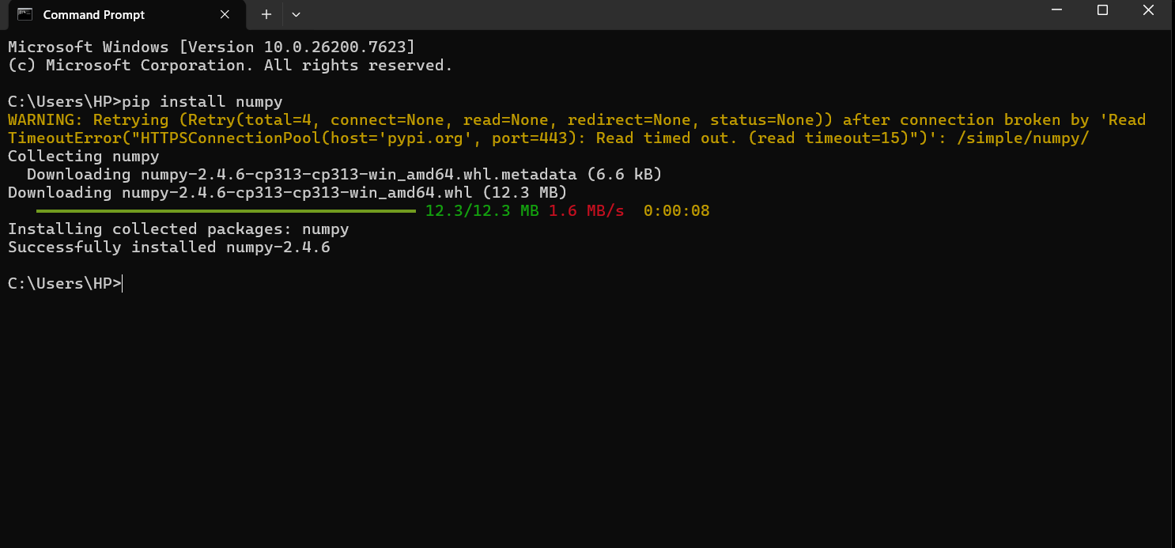
Figure 2: Installation and setup of Pandas library
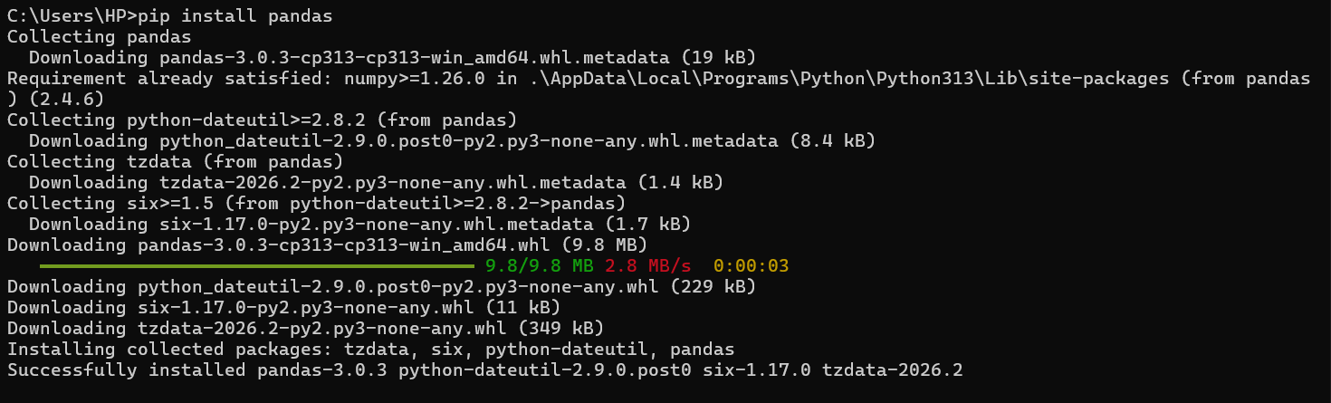
Figure 3: Installation of NLTK and supporting dependencies
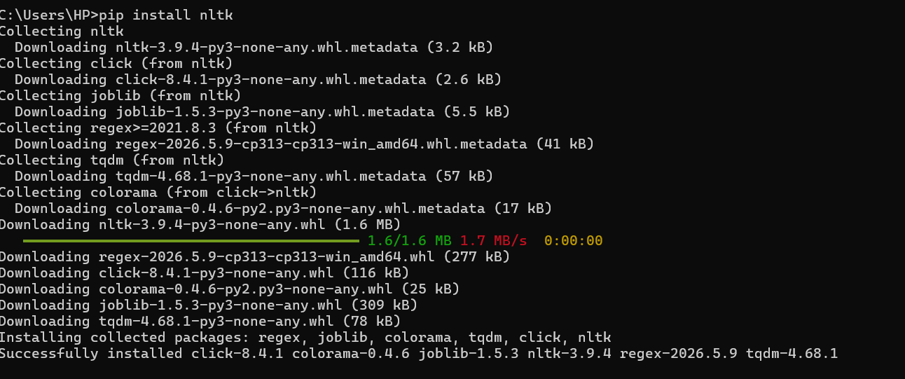
Figure 4: Installation of Sentence Transformers and associated packages
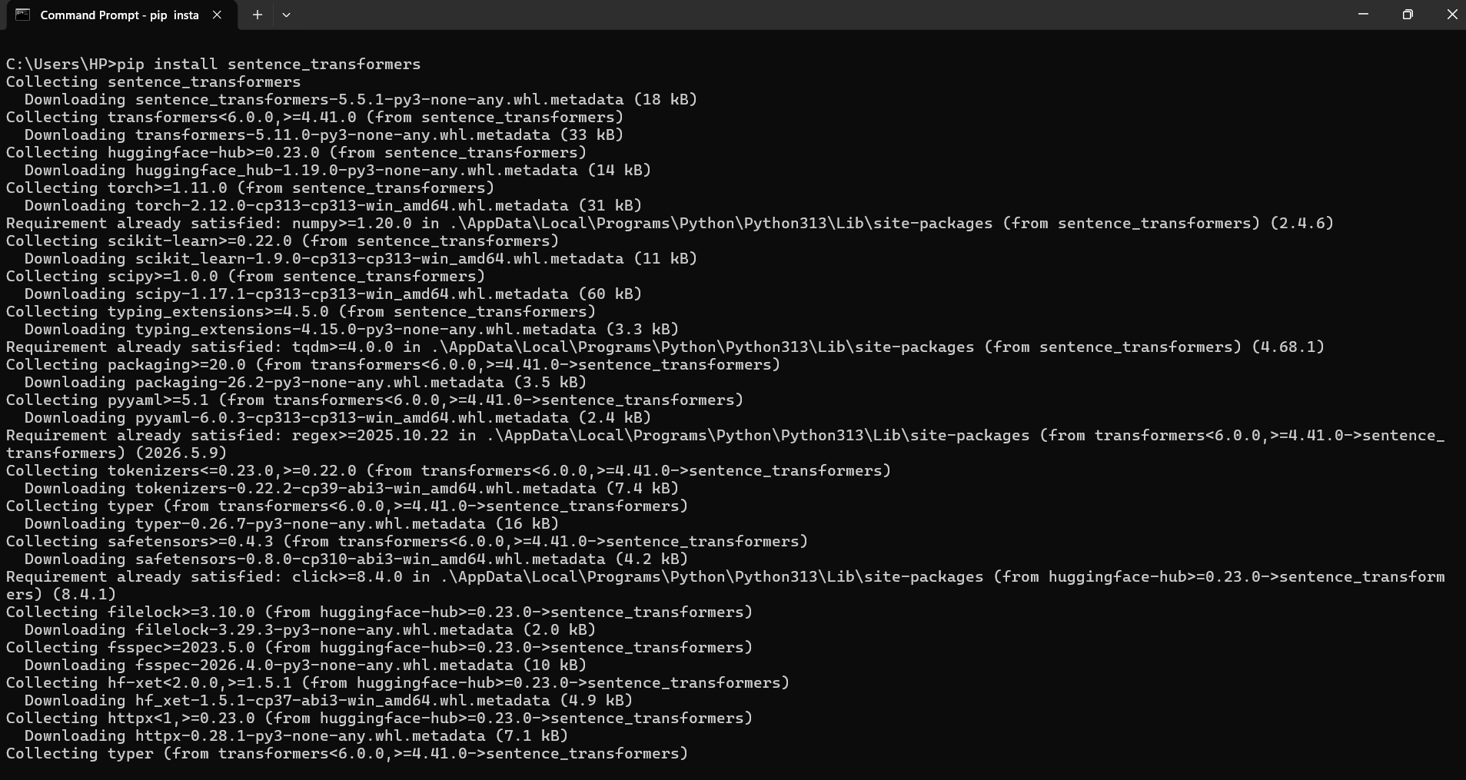
Figure 5: Successful installation of FAISS for vector similarity search
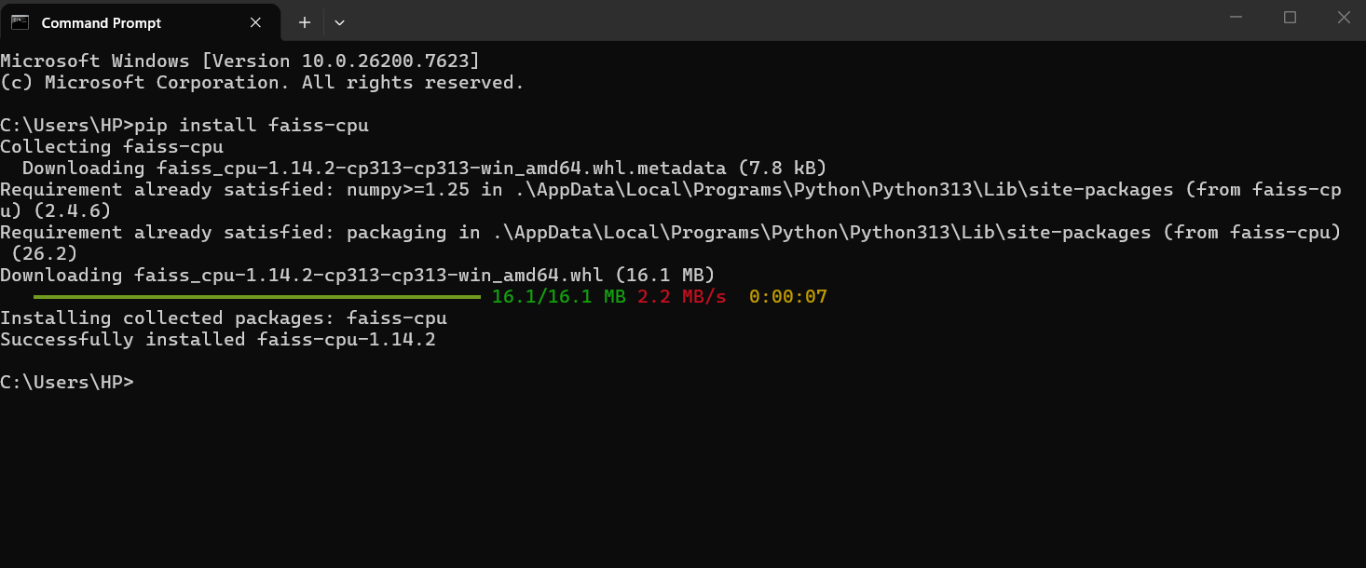
Figure 6: Python implementation demonstrating embeddings, FAISS indexing, and similarity search within VS Code
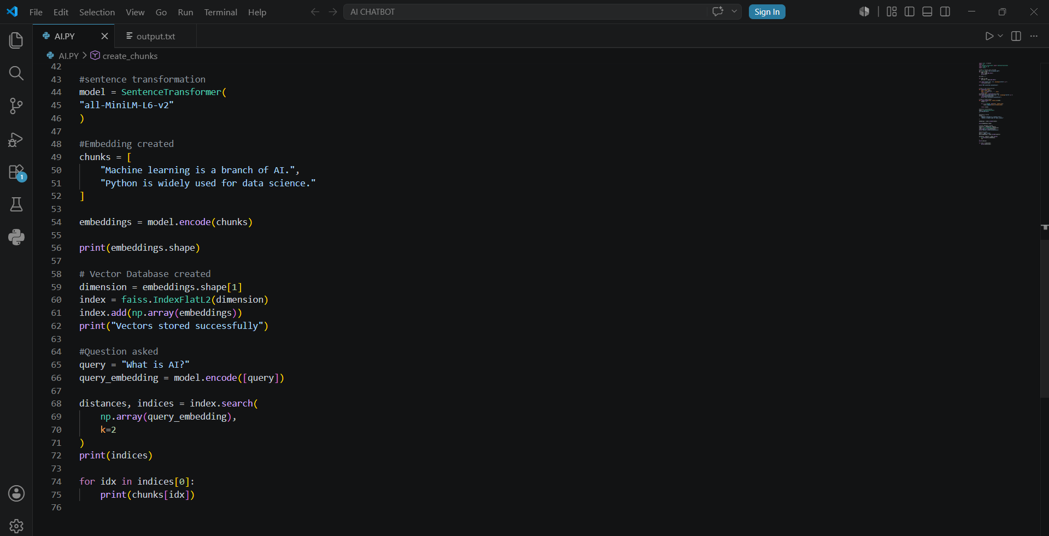

Challenges Faced
• Initially faced difficulty understanding package dependencies and installation procedures.
• Encountered confusion while relating preprocessing techniques to the overall chatbot architecture.
• Required additional study to understand embeddings.
• Understanding vector databases and similarity search required revisiting tutorials.
• Integrating concepts into a complete workflow took time and experimentation.

Plan for Next Week
• Implement text chunking techniques programmatically.
• Generate embeddings from extracted PDF text.
• Experiment with larger document collections.
• Improve the FAISS retrieval implementation.
• Study different vector database alternatives.
• Begin constructing the Retrieval-Augmented Generation pipeline.
• Integrate retrieval functionality with an LLM.

